Kevin Quizhpi

DSP Design

Kdq2

9/28/17

Project 2: Dynamic Range Control

Compressors, Limiters, Expanders and Noise Gates

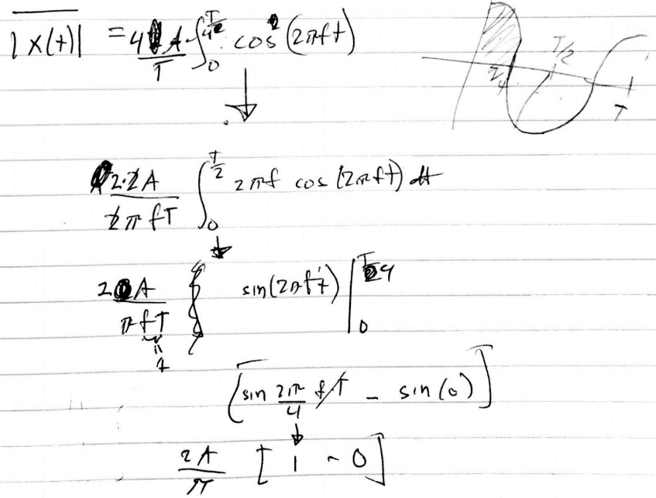 Calculating the mean-square average can be done by integrating the input function squared over a period. After working through it by hand it does simplify to A2/2

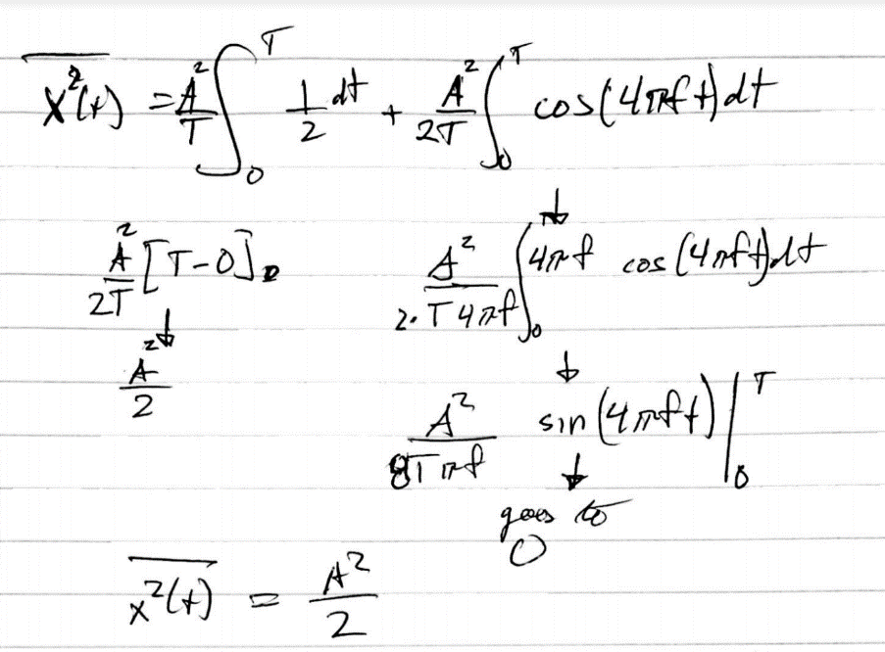 To find the absolute average I integrated the input function over a quarter period and multiplied by 4.